**Cathago Assignment**

**Introduction:**

The **Credit-Based Document Scanning System** is a web-based application designed to streamline document comparison while integrating a user-friendly credit system. Users can upload plain text files for scanning, and the system compares them against stored documents to check for similarities. The platform aims to enhance document verification accuracy using both basic text-matching techniques and AI-powered document comparison.

**Key Features:**

✅ **User Authentication:** Secure login for users with role-based access (admin & regular users).  
✅ **Credit System:** Users are allocated credits, which are deducted per document scan. Credits reset daily, and users can request additional credits.  
✅ **Document Management:** Users can upload, store, and retrieve files, categorized under different document types.  
✅ **Text Similarity Analysis:** Compares documents using algorithms like Levenshtein distance.  
✅ **Admin Panel:** Admins can approve credit requests and manage users efficiently.

**Tech Stack:**

* **Frontend:** HTML, CSS, JavaScript
* **Backend:** Python (Flask)
* **Database:** SQLite (or JSON-based storage)

**Features and Functionalities:**

1. **User Authentication:**

The system ensures secure access through authentication mechanisms, including:

* User Registration: New users can sign up with an email and password.
* Login & Logout: Users can log in securely and log out when needed.
* Role-Based Access: Users are categorized as regular users or admins, with different permissions for each role.

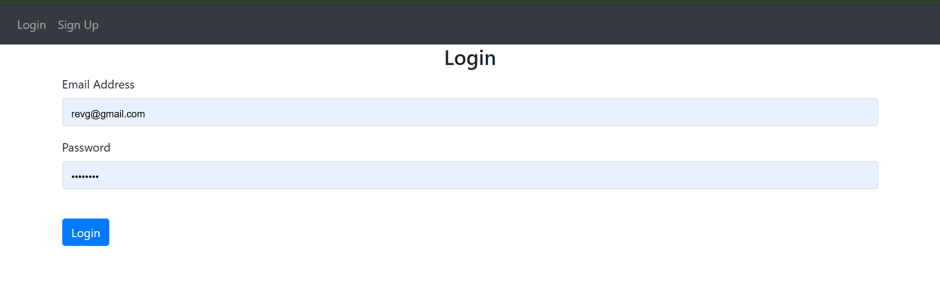

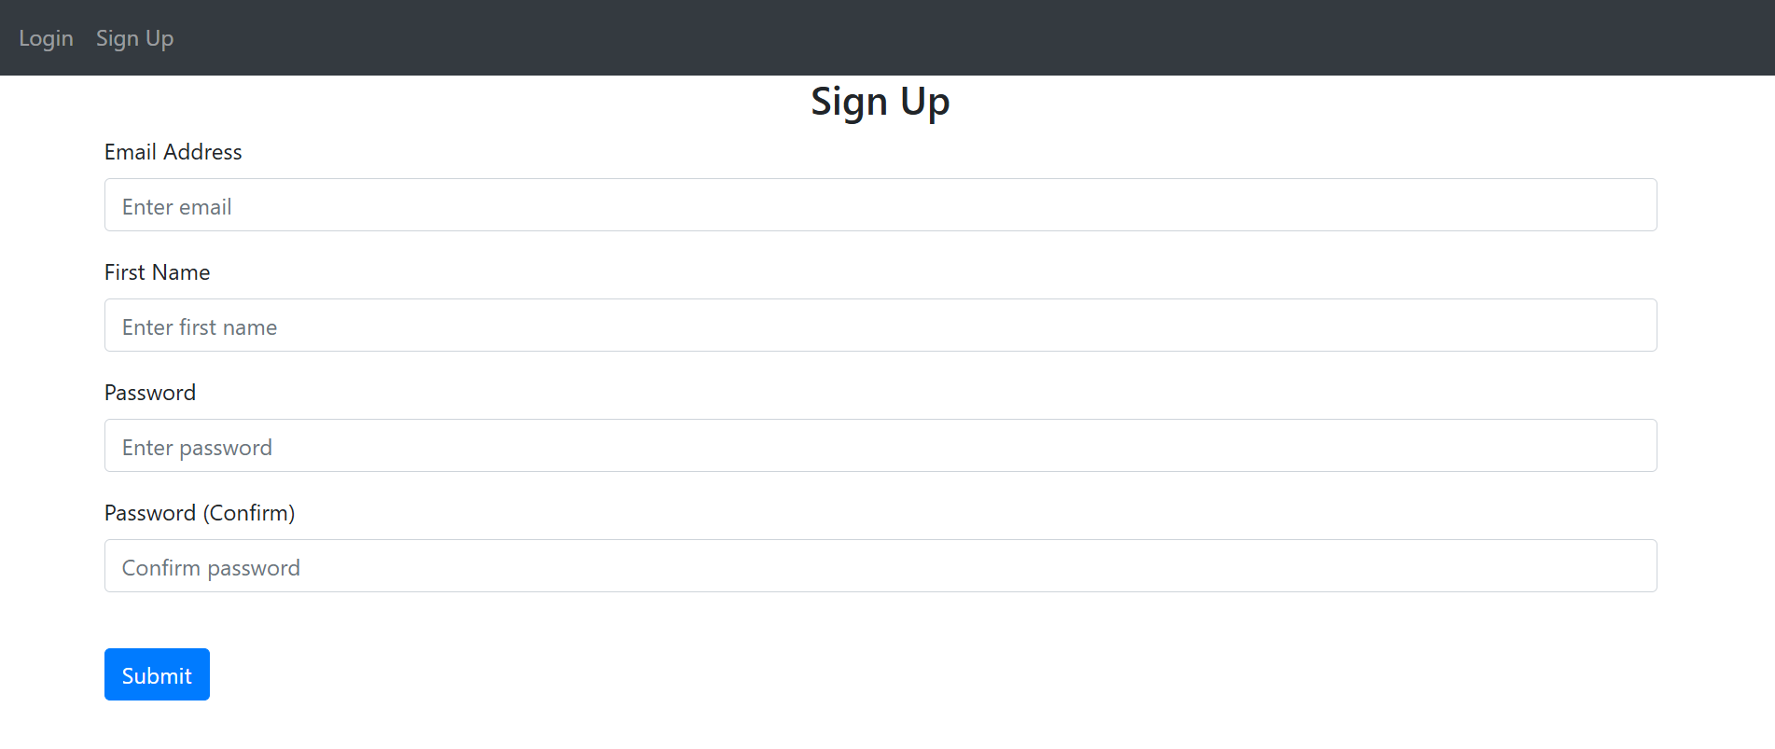

**2. Credit System**

To regulate document scanning, the system implements a credit-based mechanism:

* **Daily Credit Allocation:** Each user receives a fixed number of credits (default: 20) every day.
* **Credit Deduction:** Credits are deducted based on document scans performed.
* **Credit Reset:** If the last reset date is older than the current date, credits are automatically reset to the default value.
* **Credit Request System:** Users who exhaust their credits can request additional credits, which require admin approval.





**3. Document Upload & Storage**

Users can upload and manage documents within the system, with the following functionalities:

* **Categorization:** Documents are stored under Document1 or Document2 based on their purpose.
* **File Storage:** Uploaded documents are stored in the database in binary format along with metadata such as filename, MIME type, and upload timestamp.
* **Retrieval:** Users can view and download their previously uploaded documents.

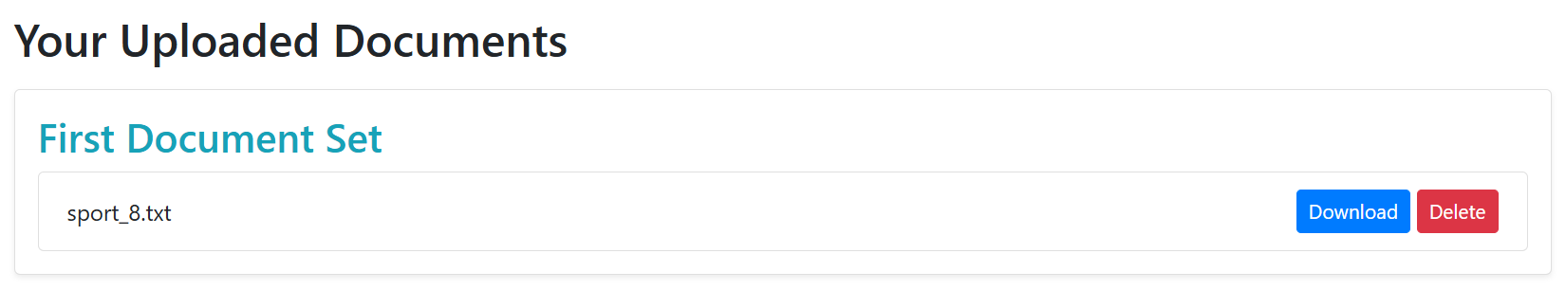

**4. Text Similarity Analysis**

The system allows users to compare documents to check for similarities using:

* **Levenshtein Distance:** A basic text similarity algorithm that calculates the number of edits required to transform one string into another.

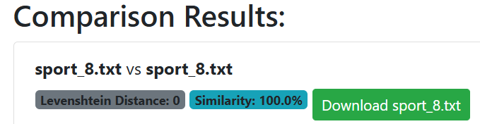

**5. Admin Dashboard**

Admins have access to a dashboard where they can manage users and system operations, including:

* **User Management:** View all registered users and their activity.
* **Credit Approvals:** Approve or reject user credit requests.
* **Document Oversight:** Access and monitor uploaded documents for compliance.

